***LAB MANUAL # 3:***

***Roll_no 068464***

***Submitted _by Nabila Naz***

***Submitted To Sir Kamran .***

***Bs (IT) 5th(sem) Morning***

# **CC-311 Operating Systems LAB**

# ***Practice Programs On Write() And Read()System Call***

Q1.**write the program to read the maximum of 15 character from the user and print them on screen.**

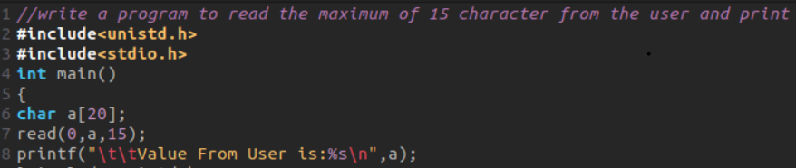

**Compilation:**

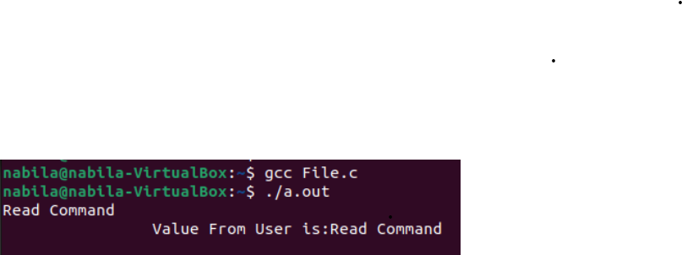

Q2**. write a program to print the count of characters read by the read() system call.**

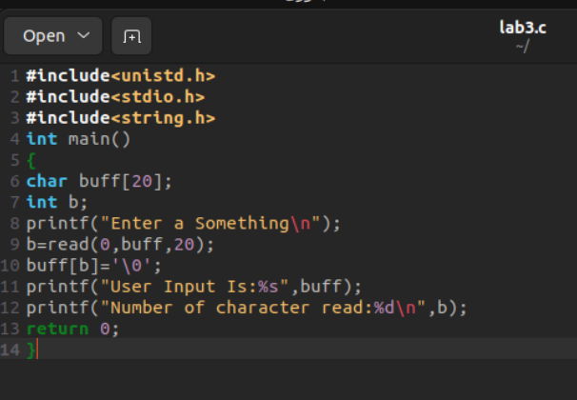

***Compilation :***

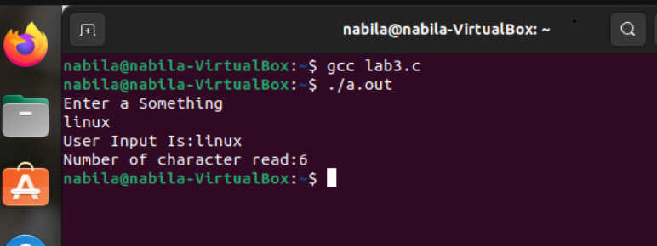

***Viva Questions:***

* **What does the write() system call return on success?**

On success, the **write()** system call returns the number of bytes successfully written.

* **What does the write() system call return on failure?**

On failure, the **write()** system call returns -1, and you can check

**errno** for the specific error.

* **Can you use write() system to send data to a printer?**

Yes, the **write ()** system call can be used to send data to a printer. Printers are treated as output devices, and **write()**can be used to write data to output device

* **Can write system be used to write into a file “xyz.txt” without knowing the file descriptor of xyz.txt?**

No, the **write()** system call requires the file descriptor of the file to

which data is being written. You must obtain the file descriptor-using **open ()** or a similar call before using  **write().**

* **How to access the manual page of write()?**

You can access the manual page of **write()** by using the **man** command in the terminal. For example, type **man write**  to view the manual page for the **write** () system call.

* **What does the read() system call return on success**

On success, the **read()** system call returns the number of bytes read. If the end of the file is reached, it returns 0. On failure, it returns -1, and you can check **errno** for the specific error.